PROJECT DESIGN PHASE
Solution Architecture
Date | 02 October 2026
Project Name | Automated Network Request Management in ServiceNow
Maximum Marks | 4 Marks

Solution Architecture
The solution architecture connects the network-service request problem with the ServiceNow components used in the current implementation. It defines how requester inputs move from the Service Catalog through variable retrieval, operational-record creation, approval, notification, and request lifecycle tracking, while also showing the responsibilities of approvers, IT administrators, and the network fulfilment team.
• Solve the problem of fragmented and manually coordinated network-service requests through a centralized digital workflow.
• Describe the structure and behaviour of the ServiceNow solution from request submission through approval and fulfilment handoff.
• Define the major functional blocks used in the current implementation and show how request data and control decisions move between them.
• Support maintainability through Flow Designer-first automation, structured operational data, controlled access, and traceable execution.
Solution Architecture Diagram
USER / ACCESS LAYER | SERVICENOW APPLICATION LAYER | APPROVAL / OPERATIONS LAYER
Requester / End User | Network Request Catalog Item | Approver
ServiceNow Service Portal | Catalog Variables + Requester Information | Approval Request Relationship
 | Catalog UI Policy | Network Fulfilment Team
 | Flow Designer | IT Administrator
 | REQ / RITM | Roles & ACLs
 | Database Tables (u_database_tables) | Flow Execution Details / Logs
 | Notifications

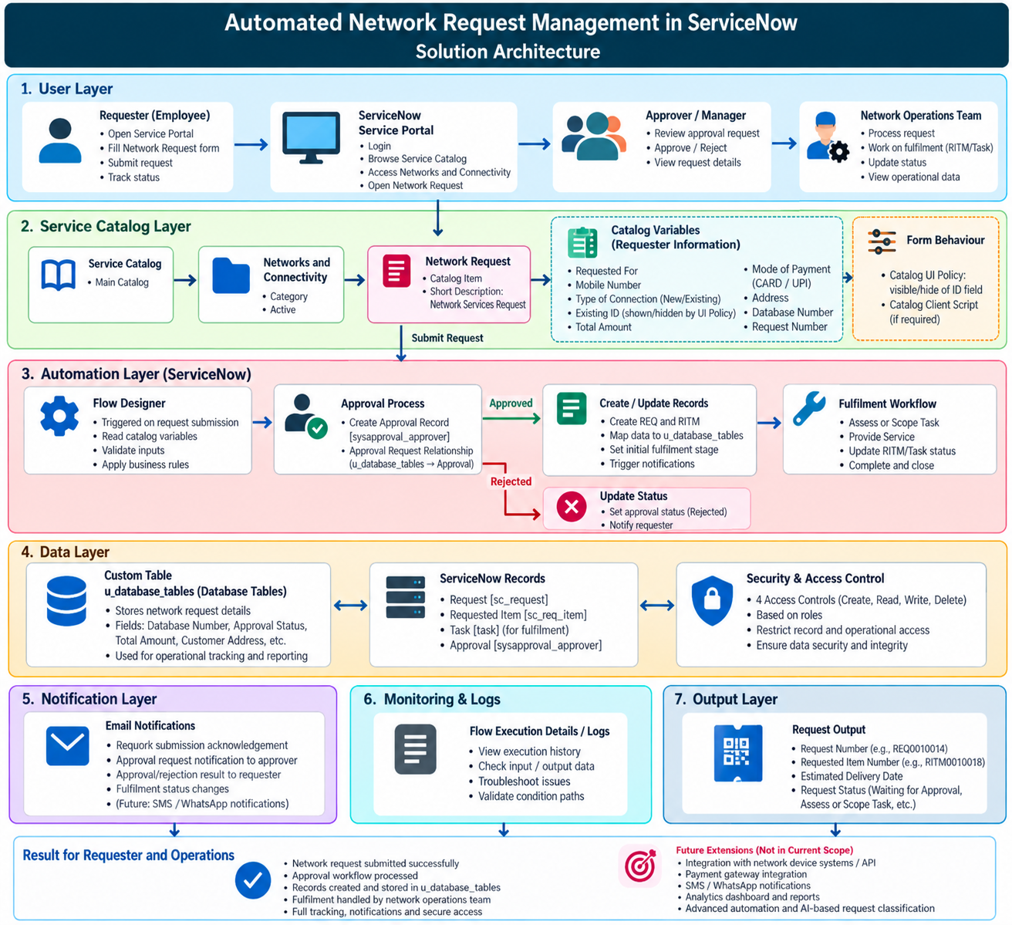
Figure 1. Solution Architecture – Automated Network Request Management in ServiceNow
Architecture Components and Responsibilities
S.No. | Component | Architecture Role | Responsibility
1 | Requester / End User | Primary request initiator | Submits the Network Request, provides required details, receives confirmation, and tracks the request lifecycle.
2 | ServiceNow Service Portal / Service Catalog | User access and request-entry layer | Provides the Network Request catalog item under Networks and Connectivity and presents the structured request form.
3 | Network Request Catalog Item | Structured request capture | Captures the configured request variables such as Requested For, Mobile Number, Type of Connection, Existing ID, Total Amount, Mode of Payment, Address, Database Number, and Request Number.
4 | Requester Information Variable Set | Reusable requester-information grouping | Groups requester-related information used by the catalog form.
5 | Catalog UI Policy | Dynamic form behaviour | Controls conditional field visibility; the current implementation includes the ID-field visibility behaviour.
6 | Flow Designer | Primary workflow automation engine | Retrieves catalog variables, creates the operational record, sends notifications, asks for approval, evaluates the outcome, and updates the record.
7 | REQ / RITM | Native ServiceNow request lifecycle | Maintains the submitted request and requested-item context, including request number, RITM, stage, and state.
8 | Database Tables (u_database_tables) | Operational data record | Stores mapped request information such as requester, mobile number, connection type, amount, payment mode, address, database number, request number, and approval status.
9 | Approval Request Relationship | Approval visibility / relationship | Relates Approval records to the corresponding Database Tables record using source table and document ID filtering.
10 | Approver | Decision point | Reviews the request through the configured approval action; the current flow uses an approval decision to determine the next branch.
11 | Roles & ACLs | Security and access control | Controls Create, Read, Write, and Delete access for the configured operational table according to ServiceNow security configuration.
12 | Notifications | Communication layer | Sends configured request-created and request-resolved email notifications from the automated flow.
13 | Flow Execution Details / Logs | Observability and troubleshooting | Supports investigation of variable mapping, conditions, approval paths, record creation, and notification execution.
14 | Network Fulfilment Team | Operational fulfilment layer | Receives the approved work context and performs the network-service fulfilment activities that require operational action.

End-to-End Data and Control Flow
1. The requester opens the ServiceNow Service Portal and selects the Network Request catalog item under Networks and Connectivity.
2. The requester enters the required catalog information, including requester details, mobile number, connection type, amount, payment mode, address, database number, and request number as configured.
3. The Catalog UI Policy controls the relevant dynamic form behaviour, including conditional visibility of the ID field.
4. The requester submits the catalog request, creating the native ServiceNow REQ/RITM request context.
5. Flow Designer retrieves the catalog variables from the Network Request submission.
6. The flow creates a record in the Database Tables (u_database_tables) operational table and maps the required request values into that record.
7. The flow sends a request-created notification to communicate that the request has been received.
8. The flow asks for approval and waits for the configured approval outcome.
9. If the approval result is Approved, the flow updates the operational record and sends the request-resolved notification. The request can then proceed through the fulfilment/status lifecycle.
10. If the approval result is not approved, the flow updates the operational record with the rejected outcome and routes the request to the configured alternative path.
11. The requester, approver, IT administrator, and fulfilment team use the appropriate ServiceNow records and status information according to their responsibilities.
12. Administrators can inspect Flow Execution Details and platform logs to troubleshoot mapping, approval, condition, or notification issues.

Architecture Design Principles
Principle | Application in this Project
Low-code first | Flow Designer is the primary automation mechanism; custom scripting is kept limited to configuration needs.
Separation of concerns | Portal/catalog, form behaviour, workflow automation, operational data, approval, security, notification, and troubleshooting are treated as distinct responsibilities.
Centralized request data | Submitted information is mapped into a structured operational record instead of remaining only in the catalog submission.
Controlled access | Roles and ACLs provide controlled access to the operational table and administrative capabilities.
Traceable lifecycle | REQ/RITM context, approval state, operational record status, and notifications provide a traceable request path.
Maintainability | The configuration-first architecture is intended to be understandable and modifiable by ServiceNow administrators.

Current Boundary and Future Expansion
The current architecture covers catalog-based request capture, dynamic form behaviour, Flow Designer automation, REQ/RITM request context, the Database Tables operational record, approval processing, notifications, access control, and workflow troubleshooting. The following items are future expansion points rather than completed capabilities:
• Additional network request categories and specialized catalog items.
• Multi-level or role-specific approval chains beyond the current configured approval path.
• Automated fulfilment through network-device or external infrastructure APIs.
• Advanced SLA, escalation, dashboard, and operational analytics capabilities.
• External SMS, WhatsApp, or other messaging channels.
• AI-assisted request classification, prioritization, anomaly detection, or intelligent routing.

End of Solution Architecture

